Line Block - Claro Empresas
Mobile Line Block — Claro Empresas
Classification: Internal Use
ITIL Category: Incident Management / Service Request
System: Minha Claro Empresas
Responsible for execution: Service Desk / Telecom / IT Support
Objective: Perform the blocking of a corporate mobile line in cases of loss, theft, or administrative request.
1. Objective
Establish the standard procedure for blocking corporate mobile lines through the Claro portal, ensuring information security, mitigation of misuse, and operational traceability.
2. Prerequisites
• Active credentials on the Minha Claro Empresas portal;• Profile with line management permission;• Confirmation of the line to be blocked;• Manager approval or ticket creation, when applicable.
3. Procedure
3.1 Portal Access
- Access the Minha Claro Empresas portal.
- Enter the administrative email in the Login field.
- Enter the access password.
- Click on Login.
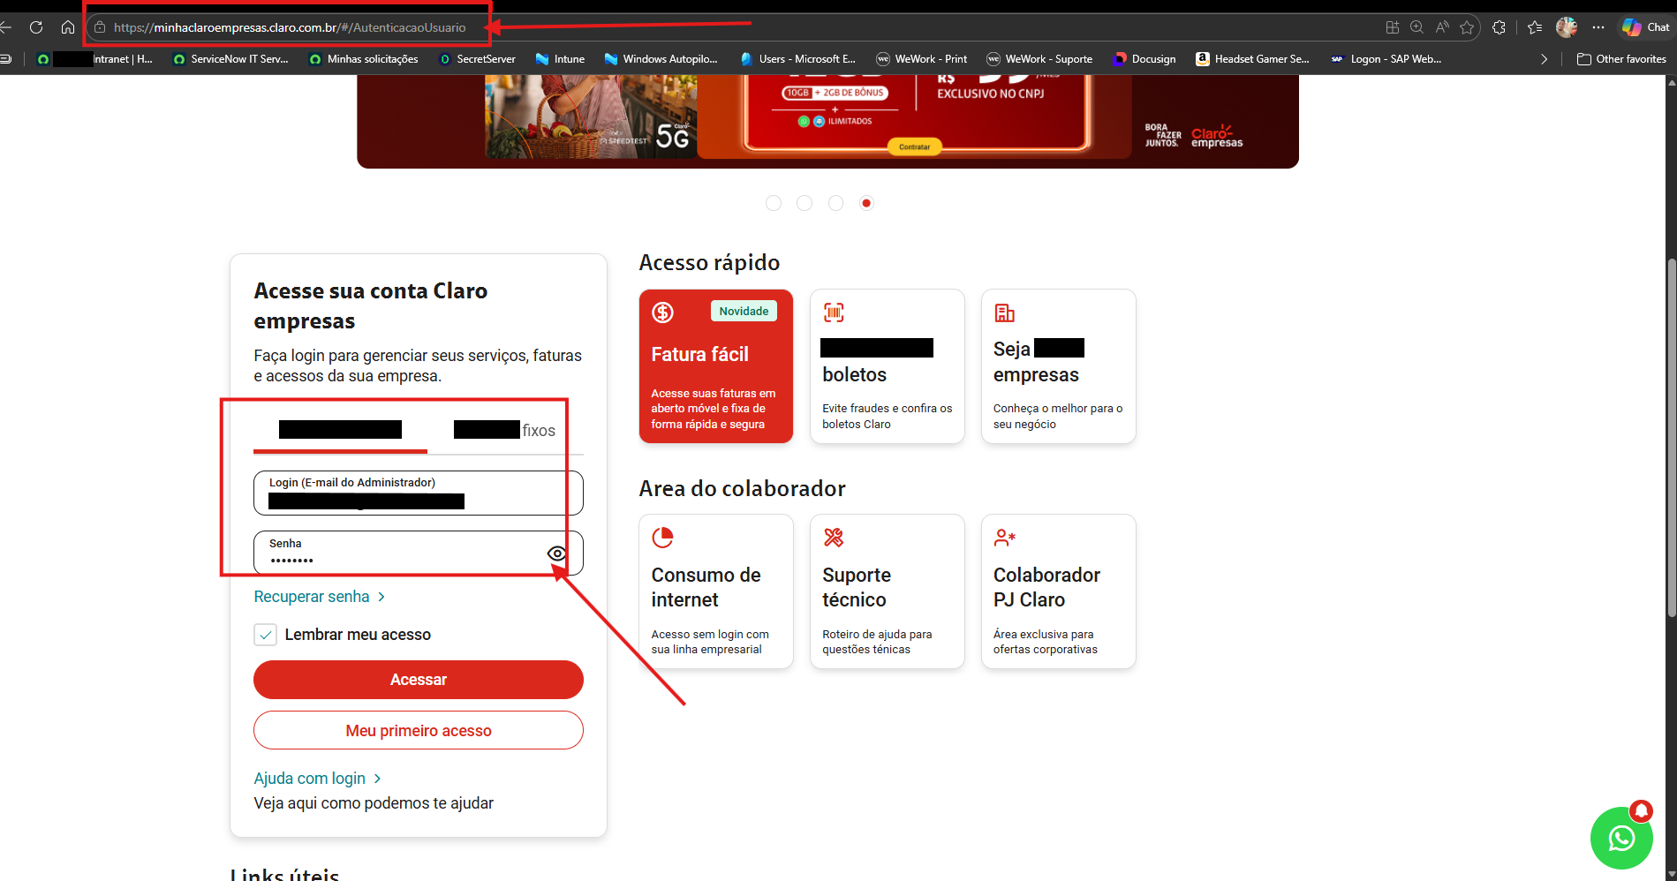
Note: On first access, you will be asked to provide a line listed in the contract; enter the number: 11-988779661
3.2 CNPJ Selection
- Select the CNPJ corresponding to the company/branch linked to the line.
- Confirm the selection.
- Click on Continue.
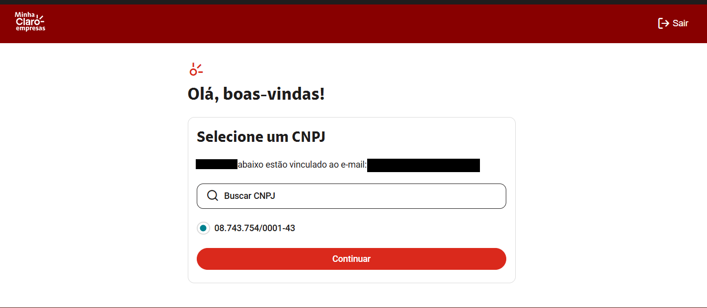
3.3 Access to the Line Manager
- Locate the Easy Navigation section.
- Select the Line Manager option.
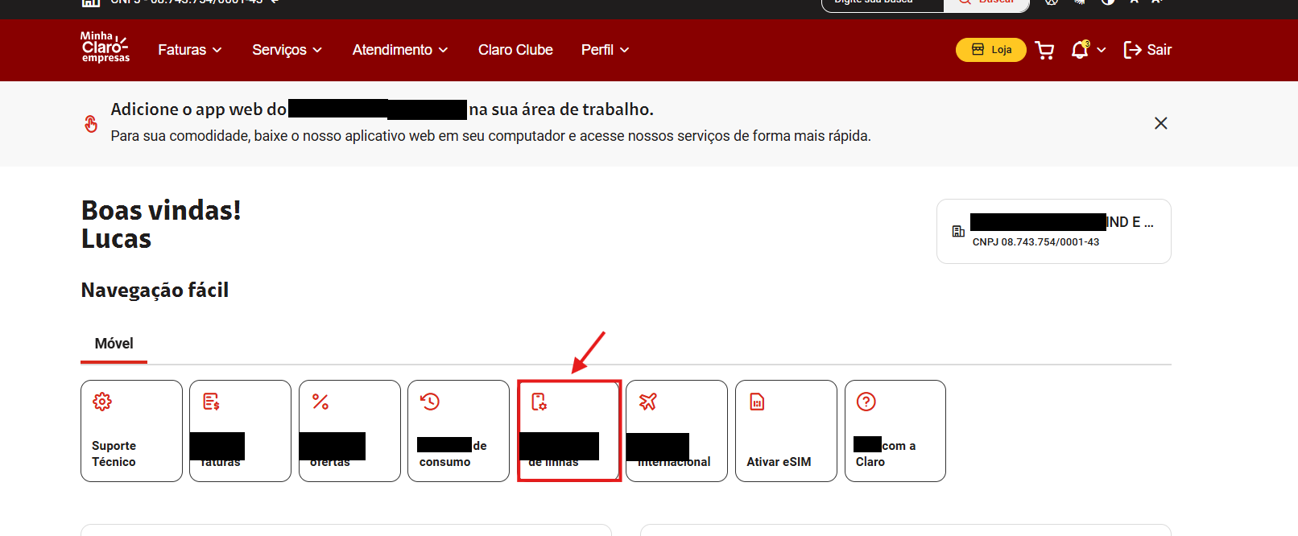
3.4 Line Selection
- Locate the desired phone number.
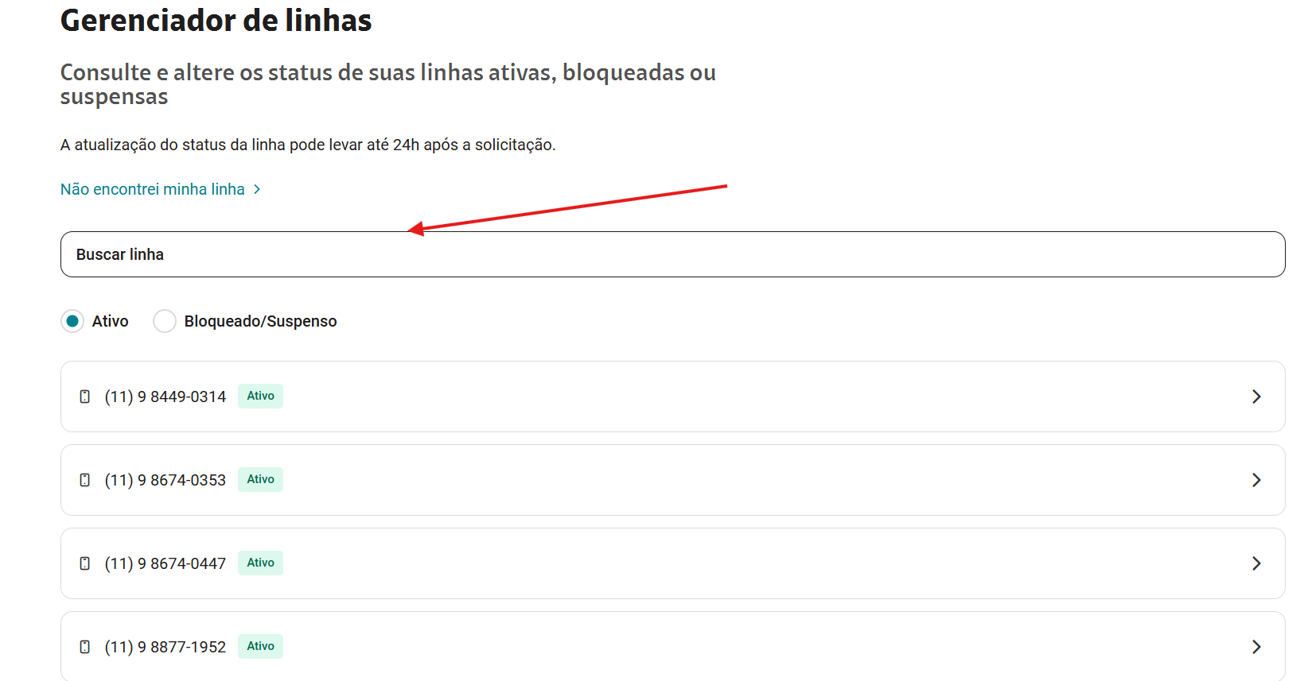
- Validate that the line corresponds to the correct user (consult lines in the spreadsheet Contoso Numbers and Cellphones Inventory (BR).xlsx)
- Select the Block option.
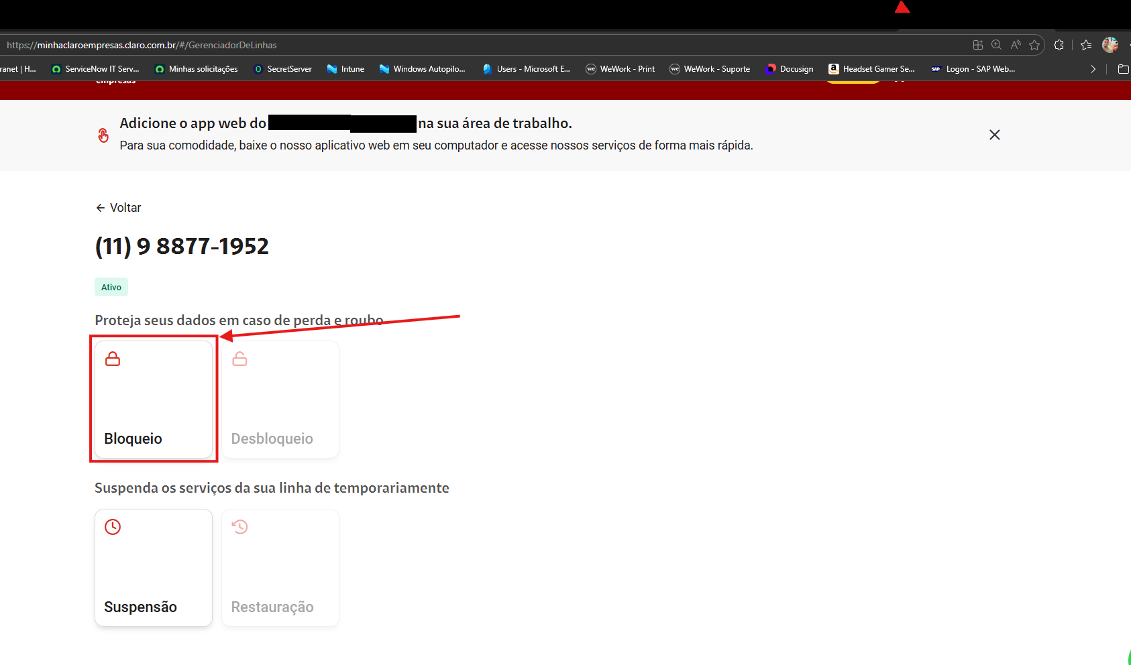
3.5 Block Request
- Confirm the displayed number.
- Select the Block Reason field.
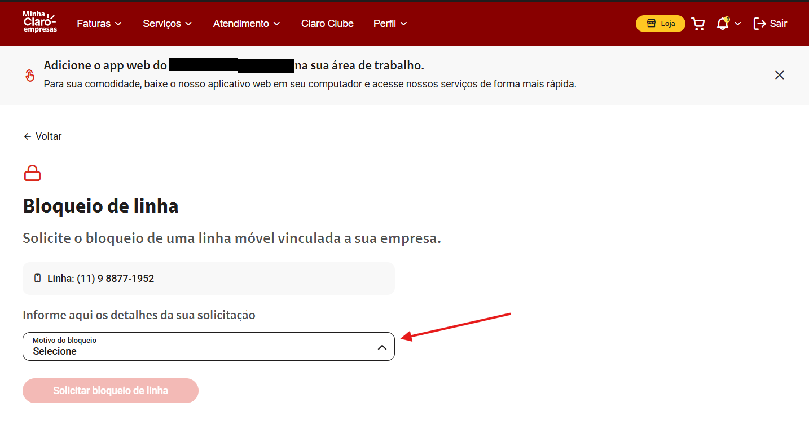
- Choose the appropriate reason.
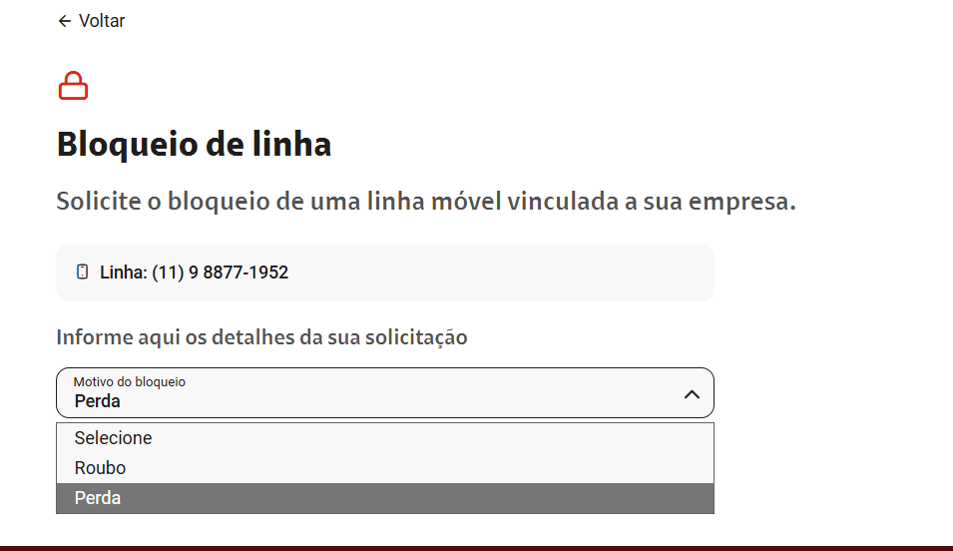
- Click on Request Line Block.
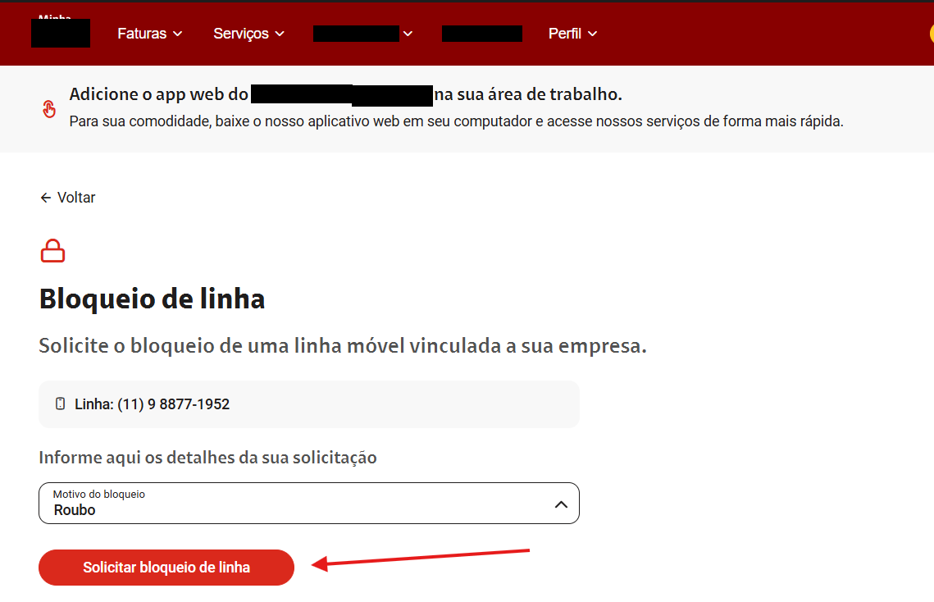
4. Post-Execution Validation
- Validate the confirmation message on the portal.
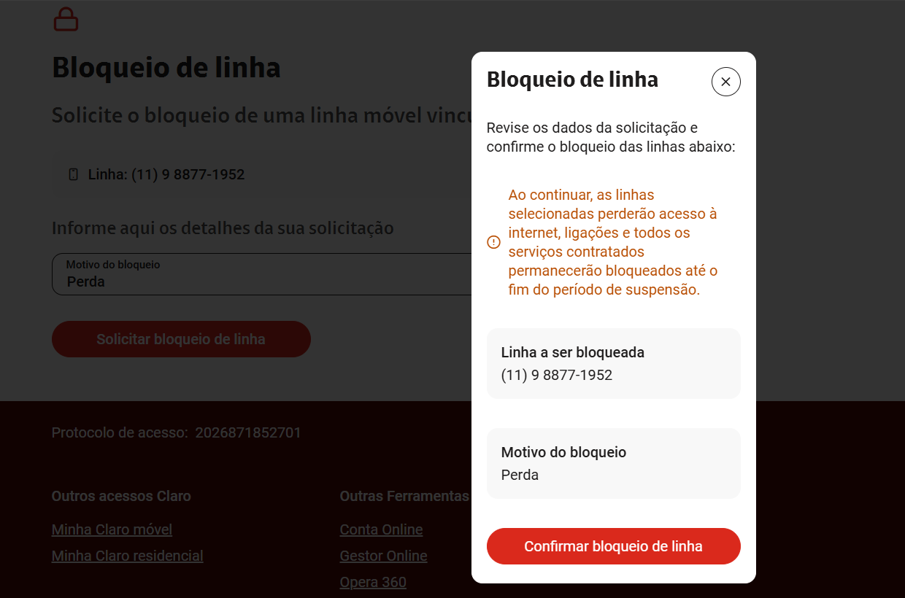
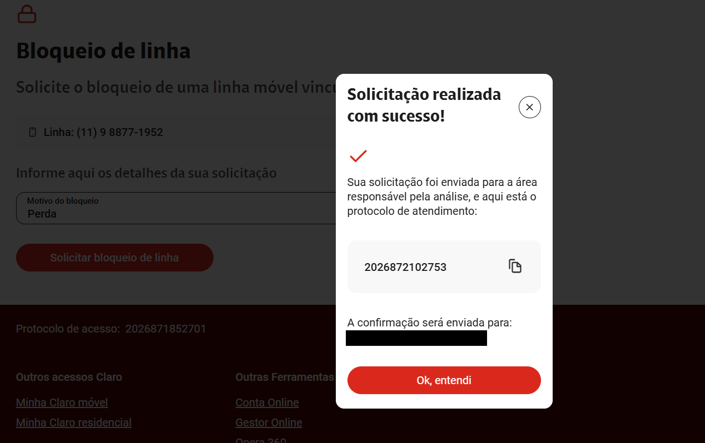
- Record the generated protocol number (when available).
- Update the case/ticket in ServiceNow.
Notify the requesting user and responsible manager.
5. Controls and Security
Execute the block immediately after notification of loss or theft.
Never share portal credentials.
Record all executions in the REQ opened for the case.
Maintain procedure evidence for audit purposes.
6. Escalation Criteria / Consulting Engagement
Portal unavailable.
Line not found.
Error in the request.
Block not executed.
CNPJ or profile registration discrepancy.
7. Expected Result
The mobile line shall remain blocked for calls, SMS, mobile data, and services linked to the carrier.

Version History
Version | Date | Description
1.0 | May/2026 | Initial procedure creation
Lucas Souza | — | Jun/2026 | Document standardization

